BLACKROTH MICROSERVICES PROJECT

EPIC 07 — Task 02
API Rate Limiting & Throttling
Final Technical Documentation
Document Item | Details
Project | BlackRoth Microservices Architecture
EPIC | EPIC 07 — Advanced API Architecture, Observability & Production System Design
Task | Task 02 — API Rate Limiting & Throttling
Completion Date | 06-Oct-2026
Planned Effort | 8 Hours
Priority | High
Author | Abhishek Gande
Status | Completed, tested, committed and pushed to Git
Git Commit | 2eb9d22 — feat(api-gateway): implement Redis-based API rate limiting
Objective
Protect APIs from excessive requests and traffic spikes by implementing Redis-backed rate limiting at the API Gateway.

1. Task Overview
This task introduced centralized request-rate protection at the API Gateway. The implementation limits traffic per user within a 60-second window and prevents excessive requests from reaching downstream microservices.
Requirement | Result
Study rate limiting | Covered rate limiting, throttling, request quota, burst traffic and API abuse.
Identify protected APIs | Gateway-protected routes were used; User API was the primary validation endpoint.
Define rule | 100 requests per minute per user.
Configure Redis | Redis runs on localhost:6379.
Implement at Gateway | RateLimitFilter checks requests before forwarding.
Handle exceeded quota | HTTP 429 Too Many Requests.
Test normal traffic | HTTP 200 with rate-limit headers.
Test excessive traffic | 101-iteration Postman run; iteration 101 returned 429.
Deliver | Documented, committed and pushed to GitHub.

2. Technologies and Tools
Technology / Tool | Purpose
Java 25 | Gateway filter implementation
Spring Boot 4.1.1 | Application framework
Spring Cloud 2025.1.3 | Gateway infrastructure
Servlet OncePerRequestFilter | Intercepts requests before downstream processing
Redis | Stores short-lived per-user counters
Docker | Runs Redis locally
Postman | Functional and load-style validation
Maven | Build/package verification
Git / GitHub | Version control and delivery

3. Benefit from EPIC 07 Task 01
Task 02 builds directly on Task 01. The Gateway already acts as the common entry point for User, Order, Product and Payment services, so rate limiting can be enforced centrally instead of duplicating traffic-control logic in each service.
Task 01 Capability | Task 02 Benefit
Gateway on port 8080 | Central enforcement point
Existing Gateway routes | Protected traffic before downstream services
Request logging / X-Request-ID | Rate-limited requests remain observable
Microservice routing | Excess traffic is stopped at the edge

4. Architecture
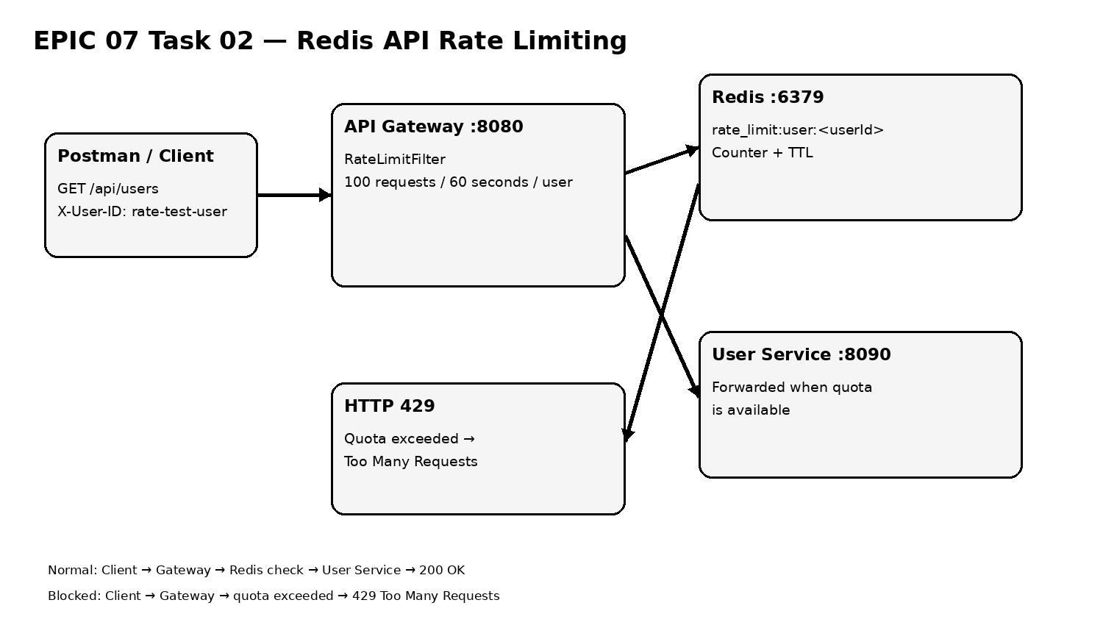
Redis stores the user-specific request counter. The Gateway forwards requests while the quota is available and stops requests once the quota is exceeded.

5. Rate-Limit Configuration
Configuration | Value
Limit | 100 requests
Window | 60 seconds / 1 minute
Scope | Per user
User identifier | X-User-ID
Redis host | localhost
Redis port | 6379
Redis key | rate_limit:user:<userId>
Exceeded response | HTTP 429 Too Many Requests
X-User-ID: rate-test-user

6. Workflow From Scratch
- Start the existing API Gateway from EPIC 07 Task 01.
- Identify the API route to protect and define a quota of 100 requests per user per minute.
- Run Redis in Docker on port 6379.
- Add Redis connection settings to application.properties.
- Create RateLimitFilter as a Spring-managed OncePerRequestFilter.
- Read X-User-ID and create a user-specific Redis key.
- Increment/check the Redis counter and apply a 60-second expiry window.
- If the quota is available, return rate-limit headers and continue the request chain.
- If the quota is exceeded, stop processing and return HTTP 429.
- Validate a normal request through Postman.
- Run 101 iterations through Postman Collection Runner and verify that iteration 101 is blocked.
- Run a clean Maven package, commit and push the changes.

7. Redis Configuration
# Redis Configuration
spring.data.redis.host=localhost
spring.data.redis.port=6379
Redis was started with Docker:
docker run -d --name blackroth-redis -p 6379:6379 redis:7
The Redis CLI was used to inspect counters and expiry.

8. Gateway Behavior
Request
↓
Read X-User-ID
↓
rate_limit:user:<userId>
↓
Check/increment Redis counter
↓
≤ 100? ── YES → rate-limit headers → forward
│
NO
↓
HTTP 429 Too Many Requests
The limiter works alongside the existing Gateway logging and request-correlation behavior; it adds protection without replacing the previously implemented Gateway observability features.

9. Test Evidence

9.1 Normal Traffic
Postman sent GET http://localhost:8080/api/users with X-User-ID: rate-test-user.
Item | Observed
HTTP status | 200 OK
X-RateLimit-Limit | 100
X-RateLimit-Remaining | 99
X-Request-ID | Returned by Gateway

9.2 Excessive Traffic
Postman Collection Runner executed 101 iterations with no intentional delay.
Metric | Observed Result
Iterations | 101
Duration | 12.555 seconds
All tests | 101
Passed | 101
Failed | 0
Errors | 0
Iteration 100 | HTTP 200
Iteration 101 | HTTP 429
Iteration 100 → 200 OK
Iteration 101 → 429 Too Many Requests
The 101st request was blocked at the Gateway, directly proving enforcement of the 100-request quota.

9.3 Redis Expiry Validation
The user-specific key was observed during testing and later expired automatically. After the 60-second window, Redis returned:
GET rate_limit:user:rate-test-user
(nil)
TTL rate_limit:user:rate-test-user
(integer) -2
Redis TTL -2 indicates that the key no longer exists, confirming expiry of the temporary rate-limit state.

10. Issues Encountered and Resolved
The initial RateLimitFilter implementation used an unavailable servlet constant for HTTP 429. It was replaced with status code 429 and the project subsequently compiled successfully.
A Redis CLI command was once entered while already inside redis-cli, producing an 'unknown command docker' message. This was only a command-context issue and not an application failure.

11. Files Changed
File | Purpose
microservices/api-gateway/pom.xml | Added Redis support required by the Gateway implementation.
microservices/api-gateway/src/main/resources/application.properties | Added Redis host/port configuration.
microservices/api-gateway/src/main/java/com/example/api_gateway/RateLimitFilter.java | Implemented user-based request limiting and HTTP 429 handling.

12. Build Verification
cd .\microservices\api-gateway
.\mvnw.cmd clean package
BUILD SUCCESS
The final clean package succeeded after all implementation changes.

13. Git Delivery
Git Item | Value
Commit | 2eb9d22
Message | feat(api-gateway): implement Redis-based API rate limiting
Files changed | 3
Changes | 93 insertions, 1 deletion
Branch | master
Push | master → master
Status | Successfully pushed to remote GitHub repository

14. Benefits
- Protects downstream services from excessive request volume.
- Provides centralized traffic control at the API Gateway.
- Uses Redis for fast, short-lived shared request-count state.
- Supports per-user quotas using X-User-ID.
- Returns a standard HTTP 429 response when the quota is exceeded.
- Reduces risk from accidental traffic spikes and API abuse.
- Keeps rate-limiting policy outside business microservices.
- Extends the Gateway architecture established in Task 01.

15. Final Status
Completion Area | Status
Rate-limit design | Completed
Redis integration | Completed
Gateway implementation | Completed
Normal traffic test | Passed — 200
Excess traffic test | Passed — 429
Redis expiry | Validated
Final Maven package | BUILD SUCCESS
Git commit | Completed — 2eb9d22
Git push | Completed
Completion date | 06-Oct-2026
FINAL STATUS: COMPLETED
EPIC 07 Task 02 — API Rate Limiting & Throttling was completed on 06-Oct-2026. The implementation was tested through Postman and Redis, the final Maven package succeeded, and the completed code was committed and pushed to Git.

16. Technical Understanding
This task demonstrates the difference between routing and traffic policy at the Gateway. Routing determines where a request goes; rate limiting determines whether the request is allowed to proceed. Redis provides the short-lived shared state needed to count requests and expire the quota window automatically.

